# Capstone Project - The Battle of the Neighborhoods (Week 1)

**Applied Data Science Capstone by IBM/Coursera**

**Downtown vs Suburbs comparison for the city of Santander**

**by Angel San Emeterio Herrera**

**Table of contents**

* [Introduction: Business Problem](http://localhost:8890/notebooks/Downloads/03_05_ASEH%20Santander%20api%20AYTO.ipynb#introduction)
* [Data](http://localhost:8890/notebooks/Downloads/03_05_ASEH%20Santander%20api%20AYTO.ipynb#data)

**Introduction: Business Problem**

In this project our goal will be to identify which streets in the furthest areas of the city of my hometown Santander, a medium size town in the north coast of Spain, are similar to the ones belonging to innermost downtown, in terms of venues and services.

In other words, we will make a comparison between two zones of the city of Santander: most internal downtown (identify as the first postal code of the city, 39001) and most external suburbs (identify as the last postal code, 39012), in order to pinpoint which areas of the latter would be similar to the former, according to the closeness of settings and places of interest.

Given that the urban development in Spain, and more precisely in Santander, focus services and venues on the downtown, while leaving certain zones in the suburbs lacking places of interest, what we will try to do is finding out to what extent this is true for the case of Santander.

That is to say, what we actually want to know is which streets in the most exterior area of the city of Santander are similar to the ones in the very center of the town.

**Data**

Based on the above definition of our problem, we will need:

* First of all, data on postal codes, streets and latitude and longitude about the city of Santander. To get this we will use **Santander city council's API**, located in the city open data repository.

<http://datos.santander.es/documentacion-api/>

http://datos.santander.es/api/rest/datasets/callejero_numpostales.json

Example of response:

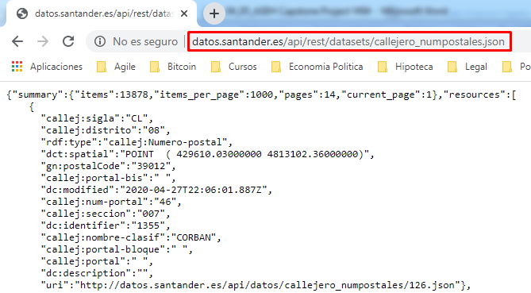

* Secondly, data on venues and their location for the city of Santander, which will be provided by using **Foursquare API**.

Example of response:

{'meta': {'code': 200, 'requestId': '5ea727553907e7001bbf3d4a'},

'response': {'headerLocation': 'Soto de la Marina',

'headerFullLocation': 'Soto de la Marina',

'headerLocationGranularity': 'city',

'totalResults': 4,

'suggestedBounds': {'ne': {'lat': 43.47202343618151,

'lng': -3.8640284446709674},

'sw': {'lat': 43.463023427181504, 'lng': -3.8764060214517078}},

'groups': [{'type': 'Recommended Places',

'name': 'recommended',

'items': [{'reasons': {'count': 0,

'items': [{'summary': 'This spot is popular',

'type': 'general',

'reasonName': 'globalInteractionReason'}]},

'venue': {'id': '4c7ea988fb74236a17d6f7b9',

'name': 'Restaurante La Tucho',

'location': {'address': 'C. Corbán, 12',

'lat': 43.466026112350335,

'lng': -3.867851926814466,

'labeledLatLngs': [{'label': 'display',

'lat': 43.466026112350335,

'lng': -3.867851926814466}],

'distance': 253,

'postalCode': '39012',

'cc': 'ES',

'city': 'San Román de la Llanilla',

'state': 'Cantabria',

'country': 'España',

'formattedAddress': ['C. Corbán, 12',

'39012 San Román de la Llanilla Cantabria',

'España']},

'categories': [{'id': '4bf58dd8d48988d1ce941735',

'name': 'Seafood Restaurant',

'pluralName': 'Seafood Restaurants',

'shortName': 'Seafood',

'icon': {'prefix': 'https://ss3.4sqi.net/img/categories_v2/food/seafood_',

'suffix': '.png'},

'primary': True}],

'photos': {'count': 0, 'groups': []}},

'referralId': 'e-0-4c7ea988fb74236a17d6f7b9-0'},

{'reasons': {'count': 0,

'items': [{'summary': 'This spot is popular',

'type': 'general',

'reasonName': 'globalInteractionReason'}]},

'venue': {'id': '4ba50e48f964a52097d638e3',

'name': 'Navajeda Sport Tavern',

'location': {'address': 'Av. Marques de Valdecilla, 59',

'crossStreet': 'CA-231',

'lat': 43.4660173303927,

'lng': -3.8759814784873257,

'labeledLatLngs': [{'label': 'display',

'lat': 43.4660173303927,

'lng': -3.8759814784873257}],

'distance': 494,

'postalCode': '39110',

'cc': 'ES',

'city': 'Soto de la Marina',

'state': 'Cantabria',

'country': 'España',

'formattedAddress': ['Av. Marques de Valdecilla, 59 (CA-231)',

'39110 Soto de la Marina Cantabria',

'España']},

'categories': [{'id': '4bf58dd8d48988d11d941735',

'name': 'Sports Bar',

'pluralName': 'Sports Bars',

'shortName': 'Sports Bar',

'icon': {'prefix': 'https://ss3.4sqi.net/img/categories_v2/nightlife/sportsbar_',

'suffix': '.png'},

'primary': True}],

'photos': {'count': 0, 'groups': []}},

'referralId': 'e-0-4ba50e48f964a52097d638e3-1'},

{'reasons': {'count': 0,

'items': [{'summary': 'This spot is popular',

'type': 'general',

'reasonName': 'globalInteractionReason'}]},

'venue': {'id': '4c63fe2186b6be9aa2d78f34',

'name': 'Casa Miguel',

'location': {'lat': 43.466708747720524,

'lng': -3.8680254861572703,

'labeledLatLngs': [{'label': 'display',

'lat': 43.466708747720524,

'lng': -3.8680254861572703}],

'distance': 198,

'cc': 'ES',

'country': 'España',

'formattedAddress': ['España']},

'categories': [{'id': '4bf58dd8d48988d150941735',

'name': 'Spanish Restaurant',

'pluralName': 'Spanish Restaurants',

'shortName': 'Spanish',

'icon': {'prefix': 'https://ss3.4sqi.net/img/categories_v2/food/spanish_',

'suffix': '.png'},

'primary': True}],

'photos': {'count': 0, 'groups': []}},

'referralId': 'e-0-4c63fe2186b6be9aa2d78f34-2'},

{'reasons': {'count': 0,

'items': [{'summary': 'This spot is popular',

'type': 'general',

'reasonName': 'globalInteractionReason'}]},

'venue': {'id': '4f0ecf5ce4b0d8e3c1cf9d0d',

'name': 'La Gallofa',

'location': {'address': 'Corban 8',

'lat': 43.46591014581848,

'lng': -3.867749859528776,

'labeledLatLngs': [{'label': 'display',

'lat': 43.46591014581848,

'lng': -3.867749859528776}],

'distance': 268,

'cc': 'ES',

'city': 'Santander',

'state': 'Cantabria',

'country': 'España',

'formattedAddress': ['Corban 8', 'Santander Cantabria', 'España']},

'categories': [{'id': '4bf58dd8d48988d16a941735',

'name': 'Bakery',

'pluralName': 'Bakeries',

'shortName': 'Bakery',

'icon': {'prefix': 'https://ss3.4sqi.net/img/categories_v2/food/bakery_',

'suffix': '.png'},

'primary': True}],

'photos': {'count': 0, 'groups': []}},

'referralId': 'e-0-4f0ecf5ce4b0d8e3c1cf9d0d-3'}]}]}}